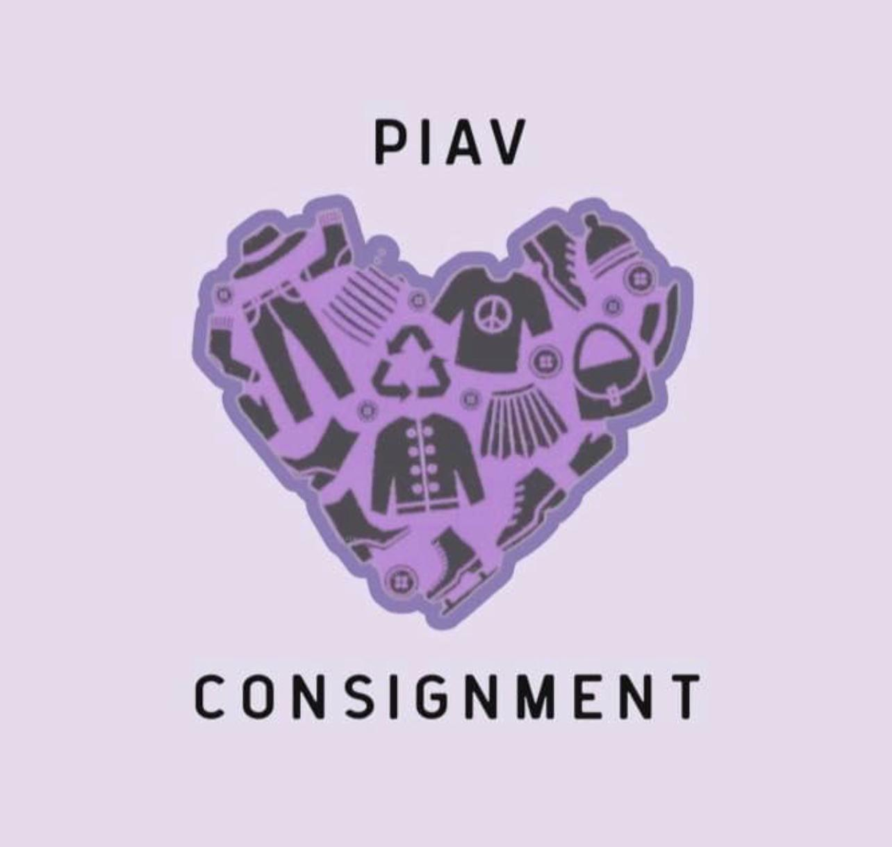
Welcome to the modern world of consignment for smart modern women!! It’s an awesome way to recycle your unwanted items and make a little cash. Or if it does not sell, have it donated to a great cause! It’s a win-win situation!

We accept items purchased within the last year and in excellent condition! Goodbrand names are preferred. This includes bridal gowns and accessories, formal wear, prom and grad dresses, casual clothing (i.e. tops and jeans), shoes, coats, boots, and jackets, suits, belts, purses and jewelry. Items are accepted by retail season:

Spring: January - March Summer: April - July
Fall: August - October Winter: October - January
We accept items for consignment 11:00 AM - 6:00 PM on Tues, Wed, and Thursdays

Consigned items are priced at the discretion of PIAV staff according to our pricing guide (i.e. setting prices between 33-50% retail prices). Casual items will remain for the duration of the current season, or up to 2 months. Evening wear and Bridal will remain on the floor for up to 6 months. Play it Again Val has the right to donate any item that does not follow the criteria outlined in our “Drop-off Guideline” on our website. Items that do not sell will be donated to a charity of our choice. Currently, we donate weekly to The Bethesda House, a shelter for abused women. We begin to discount items once they have been in the shop for half of the total allotted time (1 month for casuals; 3 months formal & bridal) as well as for notable sales such as Boxing Week or end-of-season clearance sales.

Casual items that sell to a third party accrue 40% of the final selling price in your account. Casual items include anything that are not a bridal gown, evening gown, or have a retail value of $300 or more. If you need to reclaim a casual item that has been dropped off for consignment (that is not yet expired), each item will incur a 5$ - 10$ charge. Bridal gowns, evening wear and items priced over $150 that sell to a third party accrue 50% of the final selling price in your account. If you need to reclaim an item that has been dropped off for consignment (that is not yet expired), each item will incur a 10$ - 50$ charge.

It is the account holder’s responsibility to check on the status of your account, either by phone, in-person, or using “Ricochet Go”. Pay-outs to you are made by cash, cheque or e-transfer ($3.50 fee is applied to e-transfers). Unclaimed items and payouts that are left dormant are forfeited to Play it Again Val (after 1 year for items valued over $150.00 and 6 months for all other items)

Play it Again Val is not responsible for damaged, lost, or stolen items. Please note we do use security tags and have security cameras. This contract overrides and supersedes all pre-existing contracts with Play it Again Val.

Name______________________________________ Phone__________________________

Email______________________________________Signature__________________________

